Lab 12. Analysis of Amazon Prime Dataset

i) Create a Donut chart to show the percentage of movie and tv shows.
ii) Create an area chart to shows by release year and type.
iii) Create a horizontal bar chart to show Top 10 genre.
iv) Create a map to display total shows by country.
v) Create a text sheet to show the description of any movie/movies.
vi) Build an interactive Dashboard.

Introduction to the Program.
- Amazon Prime, a popular streaming platform, offers a diverse range of movies, TV shows, and original content. This analysis demonstrates how visualizations can help uncover trends, provide insights into content distribution, and aid in decision-making processes. In this program, we analyze an Amazon Prime Dataset using Power BI, focusing on visualizing and understanding the patterns in the data.
- The dataset represents the details of movies and TV shows available on Amazon Prime. It includes key information such as titles, types (movie or TV show), genres, release years, countries, and descriptions. Analyzing such a dataset can provide actionable insights for content developers, marketers, and platform managers to understand content preferences and improve user engagement.

Introduction to the Dataset

The dataset is a simulated representation of Amazon Prime’s content library. It consists of 50 records, each detailing attributes of a specific movie or TV show.
Key fields in the dataset include:
- Title: The name of the movie or TV show.
- Type: Specifies whether it is a movie or a TV show.
- Genre: The primary genre (Theme) of the content (e.g., Drama, Comedy, Action, Thriller…).
- Release Year: The year in which the movie or TV show was released.
- Country: The primary country associated with the production of the content.
- Description: A brief synopsis or description of the content.

- Objectives of the Program
The objectives of this program are as follow-
- To understand how to analyze a structured dataset in Power BI and create meaningful insights.
- To visualize the distribution of movies and TV shows using a Donut Chart.
- To explore the trends in content release over time using an Area Chart categorized by type.
- To identify the most popular genres by creating a Horizontal Bar Chart for the top 10 genres.
- To map the geographic spread of content availability using a Map Visualization.
- To display detailed textual information for specific movies or TV shows using a Text Sheet.
- To combine multiple visualizations into a cohesive Interactive Dashboard for comprehensive analysis.
i) Create a Donut chart to show the percentage of movie and TV shows.
- Create Donut Chart:
  - Go to the Report View, Select the Donut Chart visual from the Visualizations pane.
  - Drag Type to Legend.
  - Drag Title with the count of Title to Values.
- Format the Chart:
  - Customize colors for Movie and TV Show.
  - Display percentage in labels by selecting Format-> Visuals->Label Contents->Select Category, Percentage of total

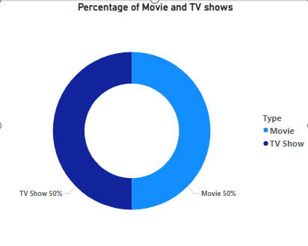
ii) Create an Area Chart to shows by release year and type.
An Area Chart is used to show trends over time, highlighting the magnitude of changes across categories. In this case, we will create an Area Chart to display the count of Movies and TV Shows for each release year, categorized by type.
- Select the Area Chart from the Visualizations pane.
- Drag Release_Year to X-Axis,
This will set the x-axis of the chart, showing the timeline of release years.
- Drag Type to Legend:
- Drag the Type column (which categorizes content as either Movie or TV Show) to the Legend field in the Visualizations pane.
- This will create separate areas in the chart for each type, allowing us to compare their trends over time.
- Drag Count to Values (ensure it aggregates properly). Drag the Title column to the Y-Axis Values field.
To show the count of titles (Movies and TV Shows) for each year:
- Drag the Title column to the Y-Axis Values field.
- Power BI will automatically aggregate the values. By default, it will calculate the Count of titles.
Ensure the aggregation is correct:
    - Click the dropdown next to the field in Values.
    - Select Count or Count (Distinct) to avoid summing numerical values unnecessarily.
- Adjust the X-axis to display all years.
By default, Power BI may group or compress the x-axis if there are too many years.
To fix this:
- Select the chart.
- Go to the Format pane (paint roller icon).
- Expand the X-axis section, Set Type to Categorical (if it is Continuous by default).
- Ensure all release years are displayed in order. Add data labels for clarity.

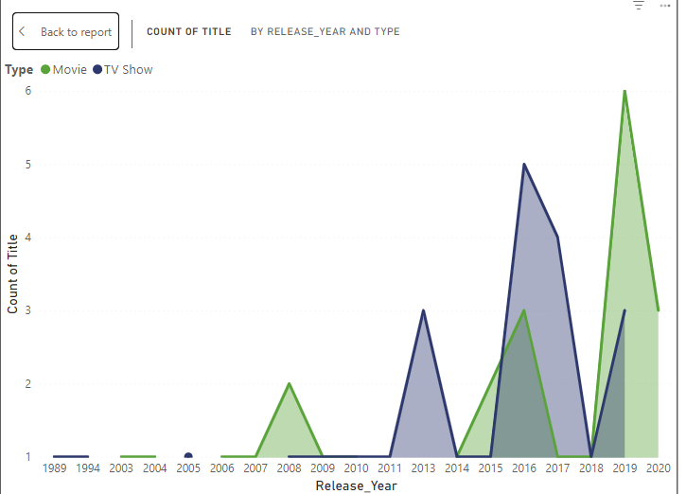

iii) Create a horizontal bar chart to show Top 10 genre.

Step 1: Select the Horizontal Bar Chart
In the Visualizations pane, select the Horizontal Bar Chart icon. This icon looks like a bar chart with horizontal bars. This will add a blank bar chart to your report canvas.

Step 2: Prepare the Dataset for the Bar Chart
We need to display the Genres and the number of times each genre appears. The data should include a Genre field and a way to count the number of items (e.g., movies or TV shows) in each genre.
- Y-axis: In a horizontal bar chart, the Y-axis represents the categories (in this case, the genres), and each genre will have a corresponding horizontal bar.
- X-axis: The X-axis will represent the values associated with each category (in this case, the count of titles or movies/TV shows in each genre), which will determine the length of the bars.
Note: We can also add a measure that shows the count of Titles or the number of shows in each genre. This will serve as the bar's length (how many movies/TV shows exist in each genre).

Step 3: Add a Measure for Count
Create a measure that counts the number of shows or movies in each genre.
To create the count:
- select New Measure.
- Enter this DAX formula:
Count of Titles = COUNTROWS('AP')
This formula counts the number of rows (shows/movies) in your dataset.
- Now, drag this new measure (Count of Titles) to the Values field well of the chart. This will represent the count of titles for each genre and will determine the length of each bar.

Step 4: Sort and Filter the Top 10 Genres
To display only the Top 10 Genres, we need to apply a filter.
- Go to the Filters pane (on the right side of the screen).
- Find the Genre field under Filters on this visual.
- Click on the Genre field dropdown and select Top N.
- In the Top N filter settings:
  - Select Top.
  - Enter 10 as the number of items.
  - For the By value, drag the Count of Titles measure into the By value field.
  - Set the Sort by to Count of Titles measure to ensure that the genres with the highest counts are shown first.

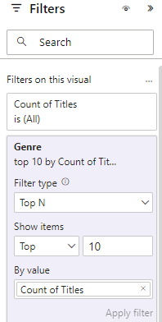

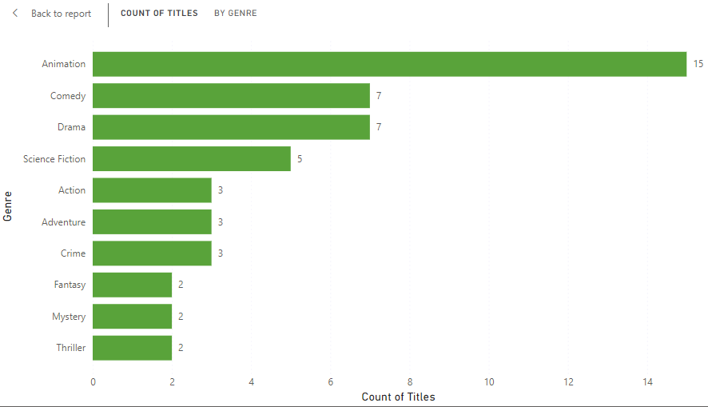

iv) Create a map to display total shows by country.

In Power BI, the Map visual allows us to plot data on a geographical map, where different areas (such as countries, regions, or cities) are represented based on data points.

Step 1: Select the Map Visual
In the Visualizations pane, find and click on the Map visual icon. The Map visual is represented by a globe icon with a location pin.

Step 2: Assign Data to the Map
For this map to display the total number of shows by country, we need to provide data fields for Location (to specify where the shows are located) and Values (to represent the total number of shows in each location).

2.1. Drag the Country Field to Location
- Drag the Country field and drop it into the Location well under the Map visual in the Visualizations pane. The location field defines the geographical points on the map. Since we are mapping by country, Country should be placed here.
- Power BI automatically recognizes common geographical names like countries, states, or cities, and maps them accordingly.

2.2. Drag the Count Column to Bubble Size
Next, we need to display the data on the map by using the Size fields.
- Size: The Size field determines the size of the markers (dots or circles) displayed on the map. Larger markers will represent higher values.
- Drag the Count of Titles measure into the Bubble Size field. This will make the size of the markers on the map correspond to the number of shows in each country.

Step 3: Review and Interpret the Map
After following these steps, your map will show the total number of shows by country using either varying marker sizes.
- Larger markers represent countries with more shows.
- Smaller markers represent countries with fewer shows.
The map will provide a geographical distribution of the shows, making it easy to spot which countries have the most shows and which ones have fewer.

Map Visual

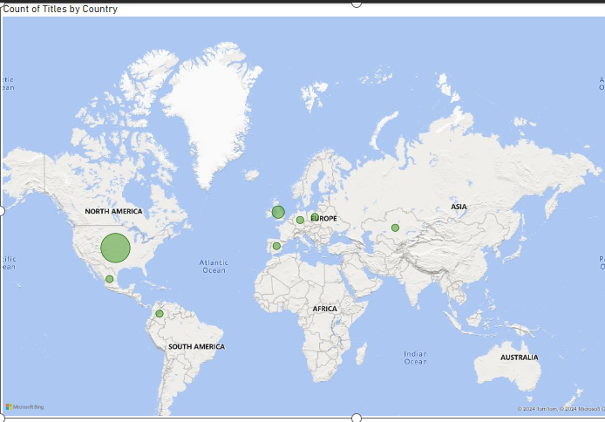

v) Create a text sheet to show the description of any movie/movies.

Text Sheet in Power BI

Is a Table or Card Visual that allows you to display textual data, such as the description of movies in this case.

Slicer in Power BI
A Slicer in Power BI is a visual tool used to filter data interactively. When applied to a text sheet or other visuals, a slicer allows users to select specific values to dynamically filter and display related information in the associated visuals. This enhances interactivity and usability by enabling focused exploration of data.

Steps to Create a Text Sheet

1. Add a Table or Card Visual
- In the Visualizations pane, select either:
  - Table: For a list of movie descriptions.
  - Slicer Users can drill down into specific details for a single movie description (useful for displaying description of one movie at a time).

2. Drag the Required Fields
- Drag the Title column from your dataset into the visual. This will display the names of the movies.
- Drag the Description column into the same visual. This will show the corresponding descriptions for the movies.

3. Filter to Show Specific Movies
- To display a specific movie or group of movies:
  - Add a Slicer from the Visualizations pane.
  - Drag the Title column into the slicer.
  - This allows users to select one or multiple movies, and the table or card visual will update dynamically to show only the descriptions for the selected movies (Hold Control key for multiple selection on the slicer).

